**Creating C# Component & Using in Pega Studio**

This is a short and simple demonstration of .NET framework's capability of creating custom component to use in the Pega studio.

Here I'm going to make a custom component and then, test my component in a Pega Studio. I have implemented some custom logging for my component.

Building the C# Component

1. Open the Visual Studio and start a new project. Your project must be based on the **Windows Control Library** template. Call your project *<* *LogReader>* and click OK.
2. Once you have your project open, delete the *UserControl* from the project. Just remove it because the 'User Control' is not exactly what we need here.
3. Now go to the 'Project' menu: **Project->Add User Control...** and select the **Custom Control** template there. 'Custom Control' is what we need in this case. You may call it LogReader. Now click OK. A new Custom control has been added to your project.
4. After that you need to add your custom method in code block like below screenshot.

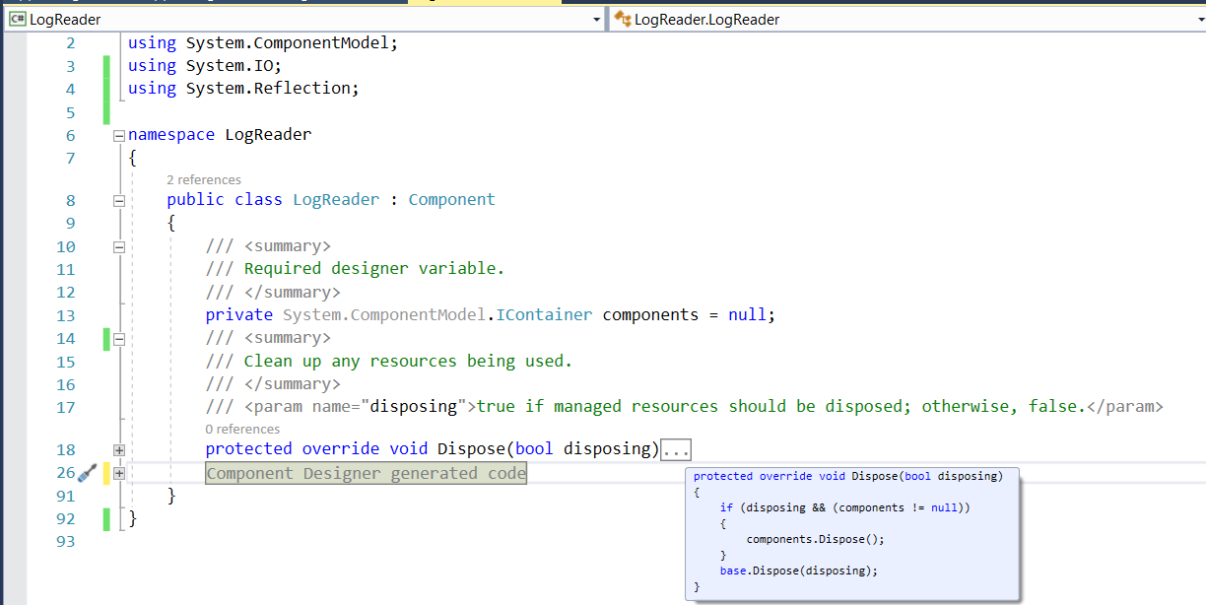 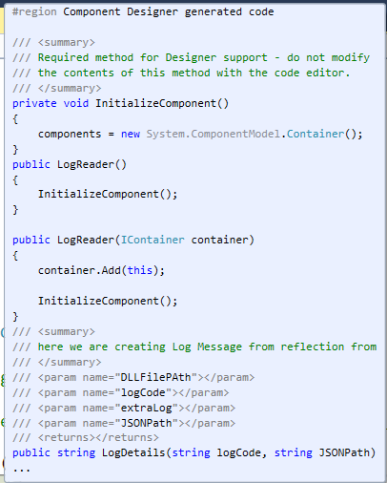

1. After complete coding and testing just do the clean and built the solution and get the DLL file from bin folder.

Using the Component in Pega studio

Now your component is ready to use in Pega studio. So please flow the below step how to add component in Pega studio.

1. This is a first and important point Place your DLL files on below folder< *C:\Program Files (x86)\OpenSpan\OpenSpan Studio for Microsoft Visual Studio 2015* > or you can create your custom name folder inside the above path only.
2. Create/open the Pega studio project and go to the toolbox and right click Pega Robotics connection or any row and the click on <Choose Items> item as per below screenshot.

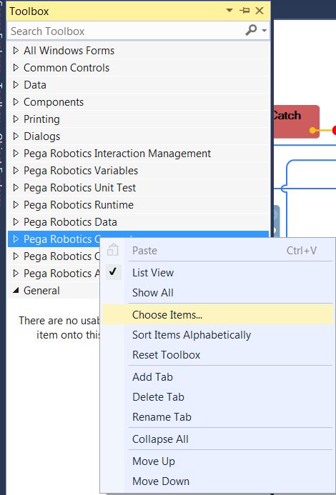

New toolbox items are added to the currently selected section by default, although they can be moved later by simple dragging and dropping. Select the section to which you would like to add the new control by clicking it. You can then begin the process of adding the new toolbox item by right-clicking the toolbox section and selecting "Choose Items" from the context-sensitive menu that appears. You can also select "Choose Toolbox Items" from the Tools menu.

1. After click on above item you will get below screenshot screen after that you need to click Browse… and select you custom component DLL and click Open.

When you select the appropriate menu option, the Choose Toolbox Items dialog box is displayed. There may be a brief delay whilst the dialog box is prepared.

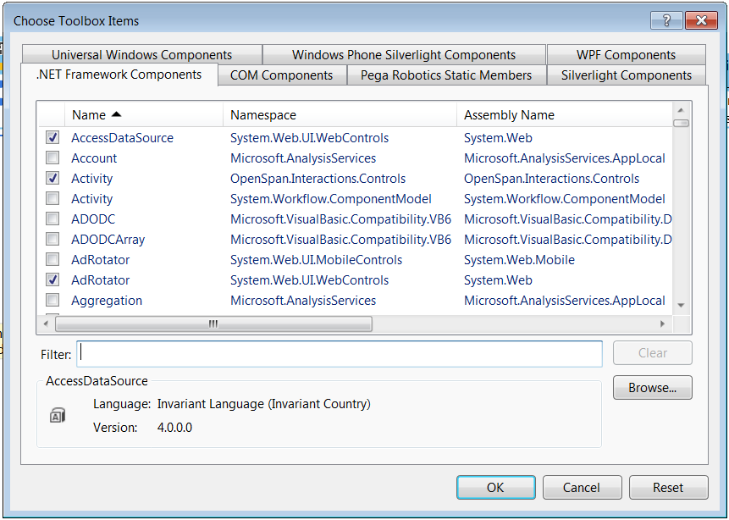

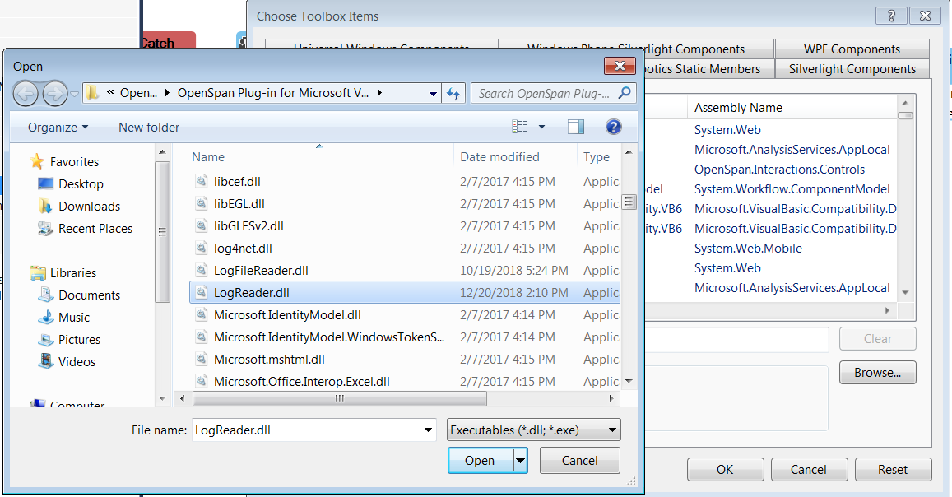

1. After add the DLL file you need filter the you DLL based on name and checked the check box as per below screenshot. And then you will see LogReader component in Toolbox.

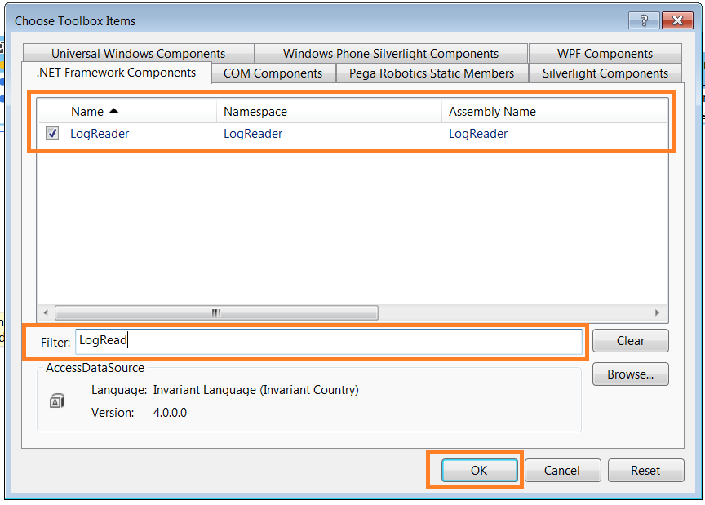 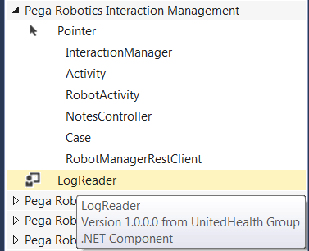

The dialog box shows several lists of items that can be included in the toolbox. Each item includes a checkbox. If the checkbox is ticked, the item is already included in the toolbox. Custom controls are not included in the lists by default so must be located manually.

To add the custom Component, click the Browse button. Use the file browser that appears to locate the LogReader.dll that you compiled earlier. Select this DLL and click the Open button to return to the Choose Toolbox Items dialog box. The LogReader control should now appear in the list. Ensure that this item's checkbox is ticked and then click the OK button. The new control will now be visible in the toolbox.

To use the toolbox item, simply drag it onto the form designer. A new LogReader control will be placed on the form. Note also that a reference to the underlying AutoSelectTextBoxControl.dll is added to the project automatically.

1. Now your component is ready to use with drag and drop in your automation see in below screenshot. And now you have reached till last step of you implementation

